5/05/2020

<https://assetstore.unity.com/packages/3d/vehicles/land/low-poly-cartoon-car-free-140598>

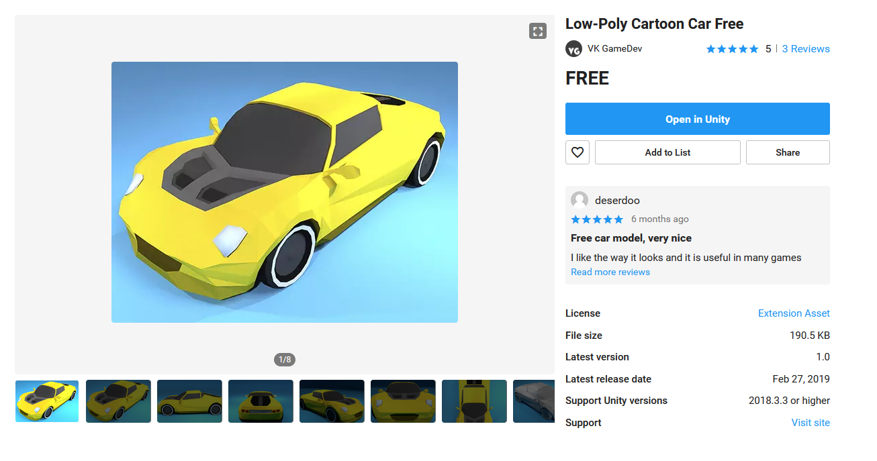

5/05/2020

<https://assetstore.unity.com/packages/3d/vehicles/land/tire-pack-147202>

